Chapter 2: Database Design Fundamentals
Solutions
Answers to Review Questions
1. An entity is a person, place, thing, or event.
2. An attribute is a property of an entity.
3. A relationship is an association between tables (entities). A one-to-many relationship between two tables is a relationship in which each row in the first table can be associated with many rows in the second table, but each row in the second table is associated with only one row in the first table.
4. A repeating group is multiple entries in a single location in a table.
5. A relation is a two-dimensional table in which the entries in the table are single-valued (each location in the table contains a single entry), each column has a distinct name (or attribute name), all values in a column are values of the same attribute, the order of the rows and columns is immaterial, and each row contains unique values.
6. A relational database is a collection of relations.
7. For each table, you write the name of the table and then within parentheses list all of the columns in the table. Underline the primary keys.
CUSTOMER (CUSTOMER_NUM, LAST_NAME, FIRST_NAME, ADDRESS, CITY,
STATE, POSTAL_CODE, PHONE)
TRIP (TRIP_ID, TRIP_NAME, START_LOCATION, STATE, DISTANCE,
MAX_GRP_SIZE, TYPE, SEASON)
GUIDE (GUIDE_NUM, LAST_NAME, FIRST_NAME, ADDRESS, CITY,
STATE, POSTAL_CODE, PHONE_NUM, HIRE_DATE)
RESERVATION (RESERVATION_ID, TRIP_ID, TRIP_DATE, NUM_PERSONS,
TRIP_PRICE, OTHER_FEES, CUSTOMER_NUM)
TRIP_GUIDES (TRIP_ID, GUIDE_NUM)

8. To qualify the name of a field, indicate the table in which the field appears. You do this by preceding the name of the field with the name of the table and a period.
9. A column (attribute), B, is functionally dependent on another column, A (or possibly a collection of columns), if at any point in time a value for A determines a single value for B.
10. Column A (or a collection of columns) is the primary key for a table if (1) All columns in the table are functionally dependent on A and (2) No subcollection of the columns in A (assuming A is a collection of columns and not just a single column) also has property 1. The primary key of the CUSTOMER table is the CUSTOMER_NUM column. The primary key of the TRIP table is the TRIP_ID column. The primary key of the GUIDE table is the GUIDE_NUM column. The primary key of the RESERVATION table is the RESERVATION_ID column. The primary key of the TRIP_GUIDES table is the combination of the TRIP_ID and GUIDE_NUM columns.
11. Functional dependencies:
DEPARTMENT_NUM → DEPARTMENT_NAME
ADVISOR_NUM → ADVISOR_LAST_NAME, ADVISOR_FIRST_NAME, DEPARTMENT_NUM
COURSE_CODE → DESCRIPTION
STUDENT_NUM → STUDENT_LAST_NAME, STUDENT_FIRST_NAME, ADVISOR_NUM
STUDENT_NUM, COURSE_CODE → GRADE

Relations:
DEPARTMENT (DEPARTMENT_NUM, DEPARTMENT_NAME)
ADVISOR (ADVISOR_NUM, ADVISOR_LAST_NAME, ADVISOR_FIRST_NAME,
DEPARTMENT_NUM)
COURSE (COURSE_CODE, DESCRIPTION)
STUDENT (STUDENT_NUM, STUDENT_LAST_NAME, STUDENT_FIRST_NAME,
ADVISOR_NUM
STUDENT_COURSE (STUDENT_NUM, COURSE_CODE, GRADE)
Entity-Relationship diagram: (NOTE: Your rectangles may be in different positions as long as they are connected by the same arrows.)
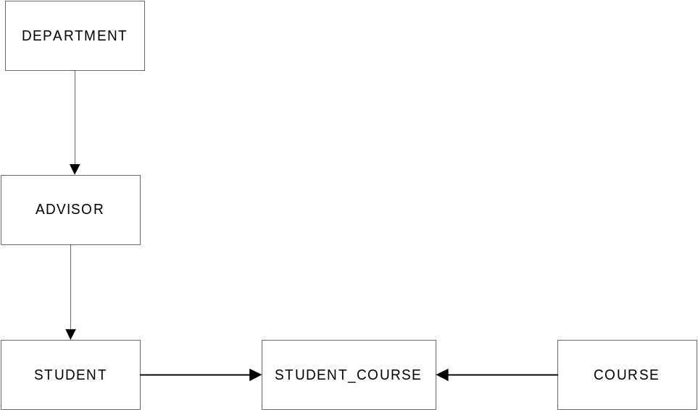
12. A table (relation) is in first normal form (1NF) if it does not contain repeating groups.
13. A table (relation) is in second normal form if it is in first normal form and no nonkey column is dependent on only a portion of the primary key. If a table is not in second normal form, the table contains redundancy, which leads to a variety of update anomalies. A change in a value can require not just one change, but several. There is the possibility of inconsistent data. Adding additional data to the database may not be possible without creating artificial values for part of the key. Finally, deletions of certain items can result in inadvertently deleting crucial information from the database.
14. A table is in third normal form if it is in second normal form and if the only determinants it contains are candidate keys. A change in a value can require not just one change, but several. There is the possibility of inconsistent data. Adding certain additional data to the database may not be possible without creating artificial rows in the table. Finally, deletions of certain items can result in inadvertently deleting crucial information from the database.
15.
STUDENT (STUDENT_NUM, STUDENT_LAST_NAME, STUDENT_FIRST_NAME,
ADVISOR_NUM)
ADVISOR (ADVISOR_NUM, ADVISOR_LAST_NAME, ADVISOR_FIRST_NAME)
COURSE (COURSE_CODE, DESCRIPTION)
STUDENT_COURSE (STUDENT_NUM, COURSE_CODE, GRADE)
16. [Critical Thinking] If a student can have more than one advisor, there is a many-to-many relatioship between students and advisors. Remove ADVISOR_NUM from the STUDENT relation and add a relation STUDENT_ADVISOR)
STUDENT (STUDENT_NUM, STUDENT_LAST_NAME, STUDENT_FIRST_NAME)
ADVISOR (ADVISOR_NUM, ADVISOR_LAST_NAME, ADVISOR_FIRST_NAME)
STUDENT_ADVISOR (ADVISOR_NUM, STUDENT_NUM)
COURSE (COURSE_CODE, DESCRIPTION)
STUDENT_COURSE (STUDENT_NUM, COURSE_CODE, GRADE)

17. [Critical Thinking] If students can repeat a course, then the STUDENT_NUM, COURSE_CODE, YEAR, and SEMESTER determine the grade.
STUDENT (STUDENT_NUM, STUDENT_LAST_NAME, STUDENT_FIRST_NAME,
ADVISOR_NUM)
ADVISOR (ADVISOR_NUM, ADVISOR_LAST_NAME, ADVISOR_FIRST_NAME)
COURSE (COURSE_CODE, DESCRIPTION)
STUDENT_COURSE (STUDENT_NUM, COURSE_CODE, YEAR, SEMESTER, GRADE)

Answers to TAL Distributors Exercises
1. NOTES: The CUSTOMER_REP table in the following lists implements the relationship between customers and reps. If customer 126, for example, is represented by both rep 15 and rep 30, there would be a row in the table in which the customer number is 126 and the rep number is 15 as well as a row in which the customer number is 126 and the rep number is 30. A row would only be allowed in the ORDERS table if the combination of the customer number and the rep number match a row in the CUSTOMER_REP table.
REP (REP_NUM, LAST_NAME, FIRST_NAME, STREET,
CITY, STATE, POSTAL_CODE, COMMISSION, RATE)
CUSTOMER (CUSTOMER_NUM, CUSTOMER_NAME, STREET,
CITY, STATE, POSTAL_CODE, BALANCE, CREDIT_LIMIT)
CUSTOMER_REP (CUSTOMER_NUM, REP_NUM)
ORDERS (ORDER_NUM, ORDER_DATE, CUSTOMER_NUM, REP_NUM)
ORDER_LINE (ORDER_NUM, ITEM_NUM, NUM_ORDERED,
QUOTED_PRICE)
ITEM (ITEM_NUM, DESCRIPTION, ON_HAND, CATEGORY,
STOREHOUSE, PRICE)
Relationships: There are one-to-many relationships from REP to CUSTOMER_REP, CUSTOMER to CUSTOMER_REP, CUSTOMER_REP to ORDERS, ORDERS to ORDER_LINE, and ITEM to ORDER_LINE.
Entity-Relationship diagram: (NOTE: Your rectangles may be in different positions as long as they are connected by the same arrows.)
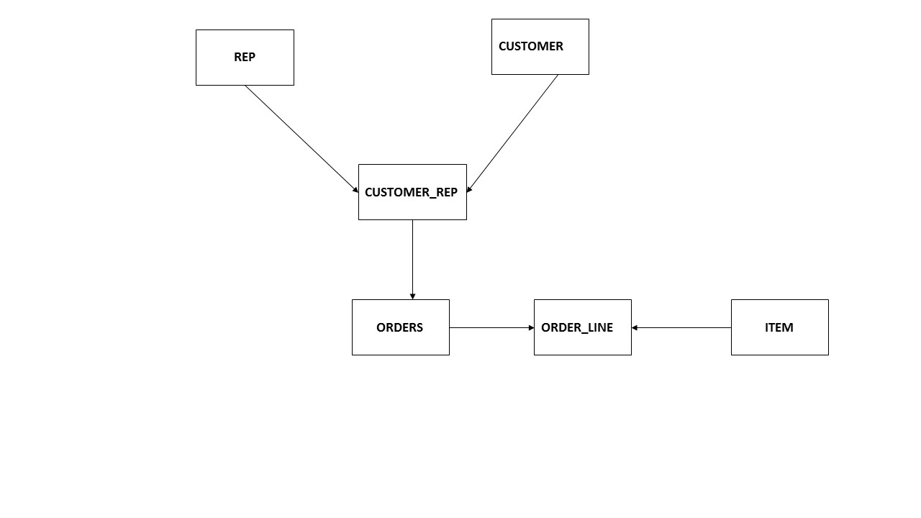
2. NOTES: There is no relationship between customers and reps, so there is no REP_NUM column in the CUSTOMER table nor is there an additional table like the CUSTOMER_REP table in Exercise 1. A row can only exist in the ORDERS table if the customer number matches a row in the CUSTOMER table and the rep number matches a row in the REP table.
REP (REP_NUM, LAST_NAME, FIRST_NAME, STREET, CITY, STATE, POSTAL_CODE,
COMMISSION, RATE)
CUSTOMER (CUSTOMER_NUM, CUSTOMER_NAME, STREET, CITY, STATE,
POSTAL_CODE, BALANCE, CREDIT_LIMIT)
ORDERS (ORDER_NUM, ORDER_DATE, CUSTOMER_NUM, REP_NUM)
ORDER_LINE (ORDER_NUM, ITEM_NUM, NUM_ORDERED, QUOTED_PRICE)
ITEM (ITEM_NUM, DESCRIPTION, ON_HAND, CATEGORY, STOREHOUSE, PRICE)
Relationships: There are one-to-many relationships from REP to ORDERS, CUSTOMER to ORDERS, ORDERS to ORDER_LINE, and ITEM to ORDER_LINE.
Entity-Relationship diagram: (NOTE: Your rectangles may be in different positions as long as they are connected by the same arrows.)
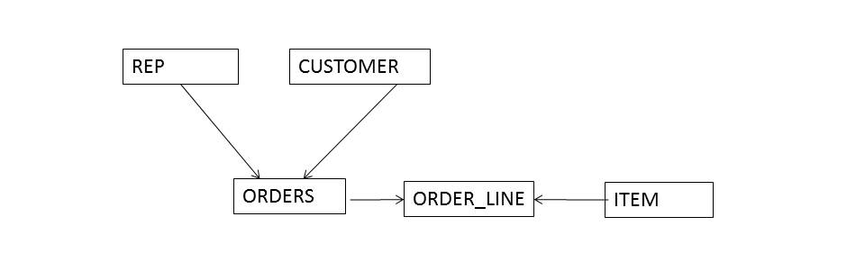
3. NOTES: The STOREHOUSE_NUM and ON_HAND columns do not appear in the ITEM table. There is a STOREHOUSE table, whose key is STOREHOUSE_NUM and which contains the STOREHOUSE description. Information about units on hand is stored in a new table, the ITEM_STOREHOUSE table, whose key is the combination of the ITEM number and STOREHOUSE number. If there are 10 units of ITEM BR23 on hand in STOREHOUSE 2, for example, there would be a row in ITEM_STOREHOUSE on which the ITEM number is BR23, the STOREHOUSE number is 2, and the number of units on hand is 10.

REP (REP_NUM, LAST_NAME, FIRST_NAME, STREET, CITY, STATE, POSTAL_CODE,
COMMISSION, RATE)
CUSTOMER (CUSTOMER_NUM, CUSTOMER_NAME, STREET, CITY, STATE,
POSTAL_CODE, BALANCE, CREDIT_LIMIT, REP_NUM)
ORDERS (ORDER_NUM, ORDER_DATE, CUSTOMER_NUM)
ORDER_LINE (ORDER_NUM, ITEM_NUM, NUM_ORDERED, QUOTED_PRICE)
ITEM (ITEM_NUM, DESCRIPTION, CATEGORY, PRICE)
STOREHOUSE (STOREHOUSE_NUM, STOREHOUSE_DESCRIPTION)
ITEM_STOREHOUSE (ITEM_NUM, STOREHOUSE_NUM, ON_HAND)
Relationships: There are one-to-many relationships from REP to CUSTOMER, CUSTOMER to ORDERS, ORDERS to ORDER_LINE, ITEM to ORDER_LINE, ITEM to ITEM_STOREHOUSE, and STOREHOUSE to ITEM_STOREHOUSE.
Entity-Relationship diagram: (NOTE: Your rectangles may be in different positions as long as they are connected by the same arrows.)
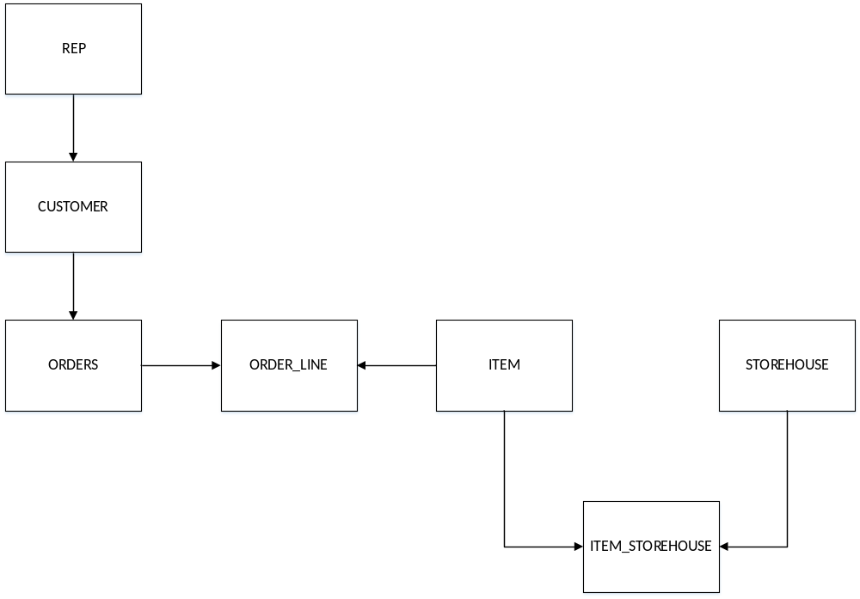
4. Functional Dependencies:
ITEM_NUM → DESCRIPTION, ON_HAND, CATEGORY, STOREHOUSE, PRICE
ORDER_NUM → ORDER_DATE, CUSTOMER_NUM
CUSTOMER_NUM → CUSTOMER_NAME
ITEM_NUM, ORDER_NUM → NUM_ORDERED, QUOTED_PRICE

Relations:
ITEM (ITEM_NUM, DESCRIPTION, ON_HAND, CATEGORY, STOREHOUSE, PRICE)
ORDERS (ORDER_NUM, ORDER_DATE, CUSTOMER_NUM)
CUSTOMER (CUSTOMER_NUM, CUSTOMER_NAME)
ORDER_LINE (ITEM_NUM, ORDER_NUM, NUM_ORDERED, QUOTED_PRICE)
NOTE: The keys for ORDER_LINE could also have been listed as ORDER_NUM, ITEM_NUM.

5. [Critical Thinking] One way to address this change is to add two tables to the database: STOREHOUSE and MANAGER.
STOREHOUSE (STOREHOUSE, MANAGER_NUM)
MANAGER (MANAGER_NUM, LAST_NAME, FIRST_NAME)

Answers to Colonial Adventure Tours Exercises
1. Many answers are possible. Here is one possible solution:
1NF but not 2NF:
TripGuides (TripID, GuideNum, TripName,)
Conversion to 2NF:
Trip (TripID, TripName)
TripGuides (TripID, GuideNum)
2NF but not 3NF:
Reservation (ReservationID, TripID, OwnerNum, LastName, FirstName)
Conversion to 3NF:
Owner (OwnerNum, LastName, FirstName)
Reservation (ReservationID, TripID, OwnerNum)

2. Functional Dependencies:
TRIP_ID → TRIP_NAME, STATE_ABBREVIATION, STATE_NAME
GUIDE_NUM → GUIDE_LAST, GUIDE_FIRST
STATE_ABBREVIATION → STATE_NAME
Tables (Relations):
TRIP (TRIP_ID, TRIP_NAME, STATE_ABBREVIATION)
STATE (STATE_ABBREVIATION, STATE_NAME)
GUIDE (GUIDE_NUM, GUIDE_LAST, GUIDE_FIRST)
TRIP_GUIDE (TRIP_ID, GUIDE_NUM)
NOTE: The TRIP_GUIDE relation is necessary to relate trips and guides. (You could have assigned it any name you like.)

3. [Critical Thinking] 3NF:
Participant (ParticipantNum, LastName, FirstName, Address, City,
State, PostalCode, Phone, BirthDate)
Class (ClassNum, Description, MaxPersons, ClassFee)
ClassParticipant (ClassNum, ParticipantNum, ClassDate, ActualNum)
FK ClassNum → Class
FK ParticipantNum → Participant

Diagram: The student’s diagram should have the following boxes (rectangles):
Guide, Trip, Reservation, Customer, TripGuides, Participants, Class
The diagram should have the following connections (arrows):
Guide to TripGuides, Trip to TripGuides, Customer to Reservation,. Participant to ClassParticipant, Class to ClassParticipant

Answers to Solmaris Condominium Group Exercises
1. Functional Dependencies
LOCATION_NUM LOCATION_NAME
LOCATION_NUM, UNIT_NUM SQR_FT, BDRMS, BATHS, CONDO_FEE
3NF
LOCATION (LOCATION_NUM, LOCATION_NAME)
CONDO_UNIT (LOCATION_NUM, UNIT_NUM, SQR_FT, BDRMS, BATHS,
CONDO_FEE)

2. Functional Dependencies:
CONDO_ID → LOCATION_NUM, UNIT_NUM, SQR_FT, BDRMS, BATHS,
CONDO_FEE, OWNER_NUM, LAST_NAME, FIRST_NAME
OWNER_NUM → LAST_NAME, FIRST_NAME

Tables (Relations):
CONDO_UNIT (CONDO_ID, LOCATION_NUM, UNIT_NUM, SQR_FT, BDRMS,
BATHS, CONDO_FEE, OWNER_NUM)
OWNER (OWNER_NUM, LAST_NAME, FIRST_NAME)

3. [Critical Thinking] Functional Dependencies
NOTE: The design assumes that the weekly rate can very with the rental agreement. If students assume that the weekly rate is always the same then the rate would be stored only in the CONDO_UNIT table. The design also assumes that both LOCATION_NUM and CONDO_UNIT_NUM uniquely identify a given condo. This is different than the way Solmaris database is designed for this text. As an alternative you can use the same design for the CONDO_UNIT table as that shown in the text.
RENTER_NUM → FIRST_NAME, MID_INITIAL, LAST_NAME, ADDRESS,
CITY, STATE, POSTAL_CODE, PHONE_NUM, EMAIL

LOCATION_NUM → LOCATION_NAME, ADDRESS, CITY, STATE, POSTAL_CODE

LOCATION_NUM, CONDO_UNIT_NUM → SQR_FT, BEDRMS, BATHS,
MAX_PERSONS, WEEKLY_RATE

RENTER_NUM, LOCATION_NUM, CONDO_UNIT_NUM → START_DATE, END_DATE,
RENTAL_RATE

3 NF
RENTER (RENTER_NUM, FIRST_NAME, MID_INITIAL, LAST_NAME, ADDRESS,
CITY, STATE, POSTAL_CODE, PHONE_NUM, EMAIL)

LOCATION (LOCATION_NUM, LOCATION_NAME, ADDRESS, CITY, STATE,
POSTAL_CODE)

CONDO_UNIT (CONDO_UNIT_NUM, LOCATION_NUM, SQR_FT, BEDRMS, BATHS,
MAX_PERSONS, WEEKLY_RATE)

RENTAL_AGREEMENT (RENTER_NUM, LOCATION_NUM, CONDO_UNIT_NUM,
START_DATE, END_DATE, RENTAL_RATE)

Diagram: The student’s diagram should have the following boxes (rectangles):
Renter, Location, Condo_Unit, Rental_Agreement
The diagram should have the following connections (arrows):
Renter to Rental_Agreement, Location to Condo_Unit, Location to Rental_Agreement, Condo_Unit to Rental Agreement

